**Create Database & Table in Hive, Demonstrate Hive Partitioning, Hive Built-In Operators, Hive Built-In Functions, Hive Views and Indexes, Hive QL: Select Where, Select OrderBy, Select GroupBy, Select Joins**

**Starting the services**

start-all.sh

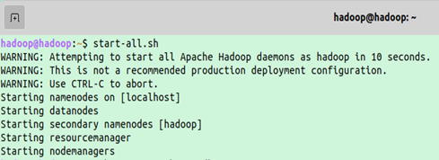

**To initiate mysql metastore**

schematool -initSchema -dbType mysql

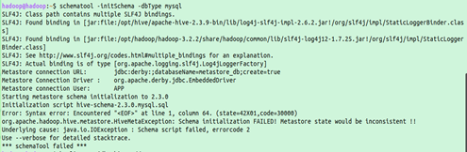

**To start hive**

beeline -u jdbc:hive2://

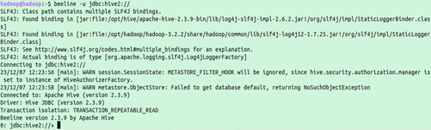

**To create Database**

CREATE DATABASE mydb1;

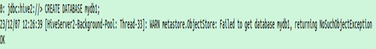

**To show database**

SHOW DATABASES;

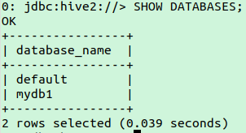

**To delete database**

drop database mydb1;

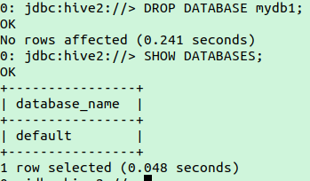

**CREATE DATABASE mydb1;**



**Use database mydb1**

use mydb1;



**Display tables in database**

show tables;

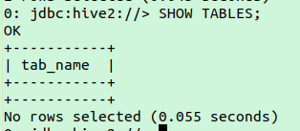

**To create table in database**

create table mydb1.employee

(

empcode INT,

empfname STRING,

emplname STRING,

job STRING,

manager STRING,

hiredate STRING,

salary INT,

commission INT,

deptcode INT

)

ROW FORMAT DELIMITED

FIELDS TERMINATED BY ','

;

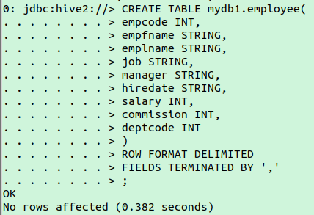

**To load data of text file into employee table**

LOAD DATA LOCAL INPATH '/home/hadoop/hive_examples/employee_data.txt' INTO TABLE mydb.employee;

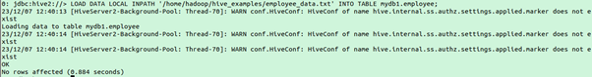

**To display all records in employee table**

Select * from mydb1.employee;

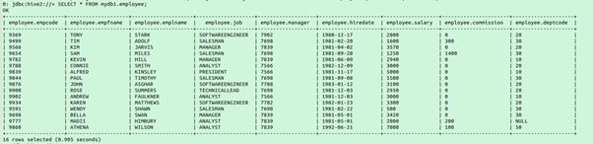

**To show table**

show create table mydb1.employee;

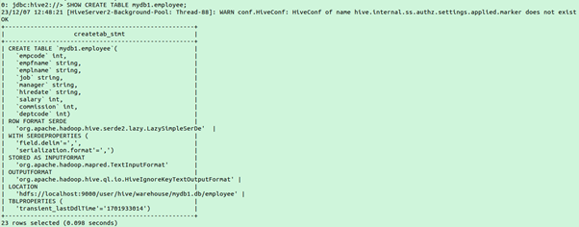

**To describe the table**

describe mydb1.employee;

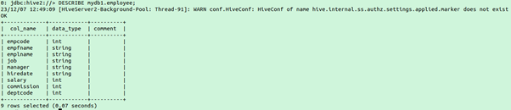

**Insert new row in employee table**

insert into mydb1.employee values (9861,'Jennifer','Huette','Analyst',7839,'1996-07-01',5000,100,50);

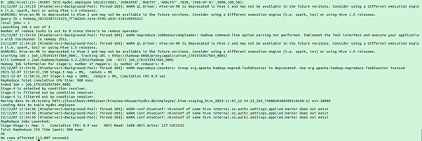

**Check record inserted or not**

select * from mydb1.employee;

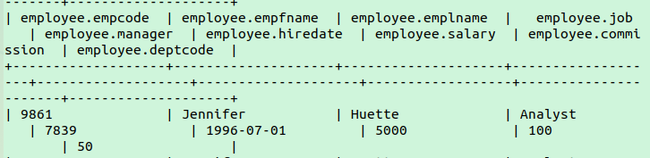

**Where query**

select empfname||" "||emplname AS empfullname, salary from mydb1.employee where job = 'ANALYST' and deptcode = 20;

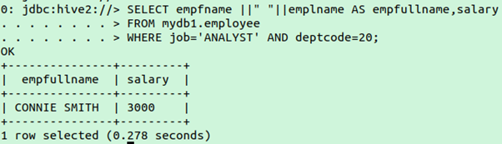

**Group by query**

SELECT job,COUNT(empfname)FROM mydb1.employee GROUP BY job;

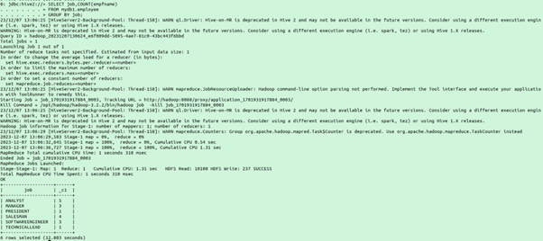

**Create directory input/dept1**

Hadoop fs -mkdir -p /input/dept1



**Copy file from local device to input/dept1 folder**

Hadoop fs -copyFromLocal hive_examples/dept_data.txt /input/dept1/



**Create external table department in mydb1 database**

create external table mydb1.department

(

deptcode INT,

deptname STRING,

location STRING

)

ROW FORMAT DELIMITED

FIELDS TERMINATED BY ','

LOCATION '/input/dept1';

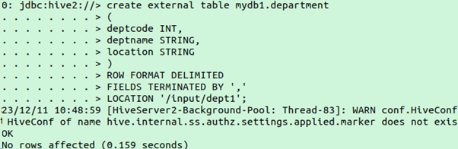

**Load the Data into department Table**

LOAD DATA LOCAL INPATH '/home/hadoop/hive_examples/dept_data.txt' INTO TABLE mydb1.department;

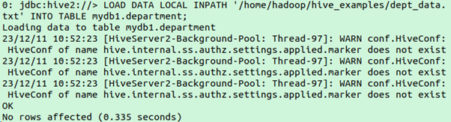

**Display all Records in department table**

select * from department;

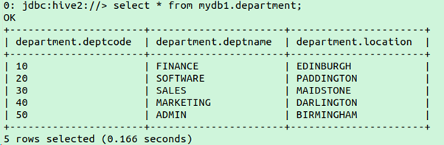

**Inner Join**

SELECT e.empfname,e.deptcode,d.deptname,d.location

from mydb1.employee e

INNER JOIN mydb1.department d

ON e.deptcode=d.deptcode;

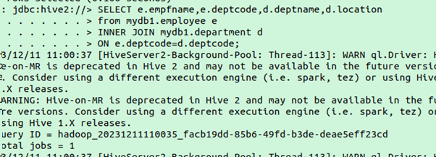

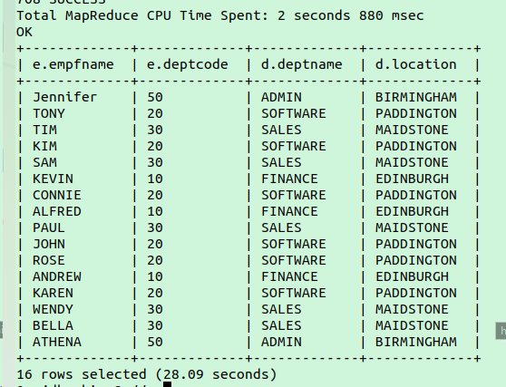

**Left join**

SELECT e.empfname,e.deptcode,d.deptname,d.location

from mydb1.employee e

LEFT JOIN mydb1.department d

ON e.deptcode=d.deptcode;

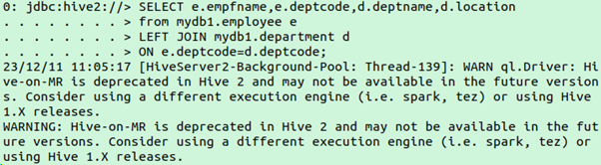

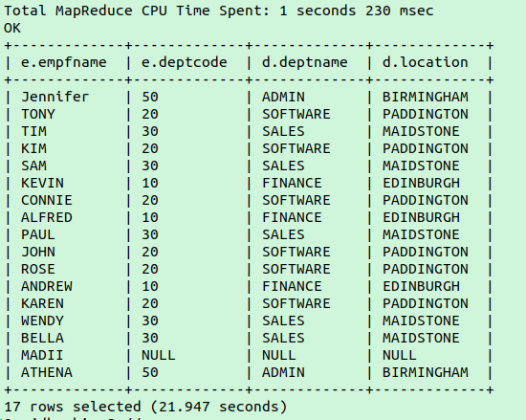

**Right join**

SELECT e.empfname,e.deptcode,d.deptname,d.location

from mydb1.employee e

RIGHT JOIN mydb1.department d

ON e.deptcode=d.deptcode;

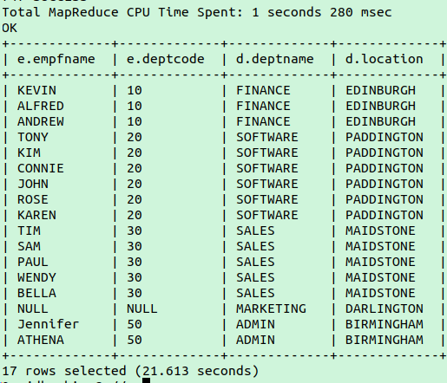

**Full Outer Join**

SELECT e.empfname,e.deptcode,d.deptname,d.location

from (SELECT empfname,deptcode from mydb1.employee where job='ANALYST')e

FULL OUTER JOIN mydb1.department d

ON e.deptcode=d.deptcode;

